1. A full stop is missing after Option. Rectify in the home page and Read More- Welcome to My Kitchen on My Plate. **Done**

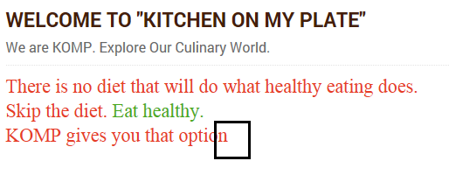

1. In the Welcome to Kitchen on My plate content - Put a space between the highlighted two lines. **Done**

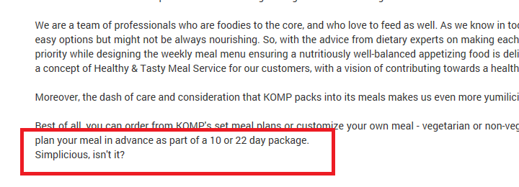

1. Lines in this orange KOMP logo is not straight:

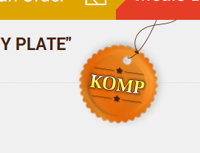

**Will ask to Mahesh about this correction**

1. In the customised tiffin service, add this icon as bulleted point for each meal.

* **Done**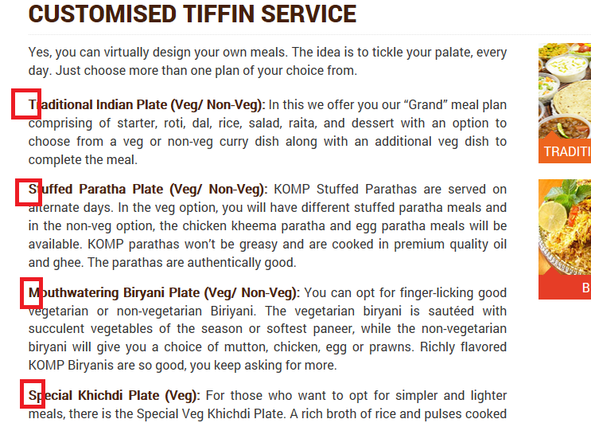

1. In the customised tiffin service: add semicolon : after from: **Done**

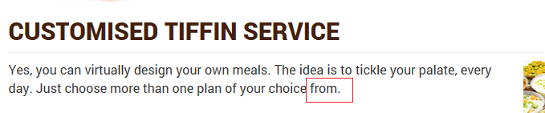

1. In the customised tiffin service Biryani spelling is wrong. **Done**

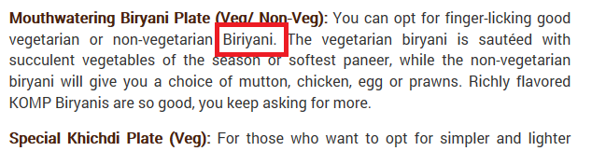

1. In customised plate: spelling of flavoured to be as flavoured. **Done**

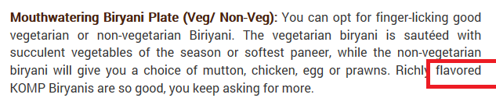

1. In customised plate: remove the line highlighted in Red and In the veg option, line will start now. **Done –might be you mean to say line should stat with word “Now”. Please confirm if need change.**

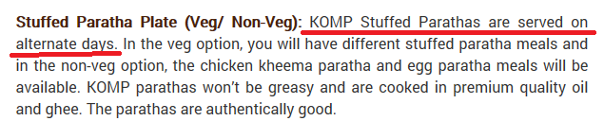

1. In customised plate: Make S in salad in caps. **In correction of Ist Aug, I replaced Salad with Pickle. Here I am little confused. Please confirm.**

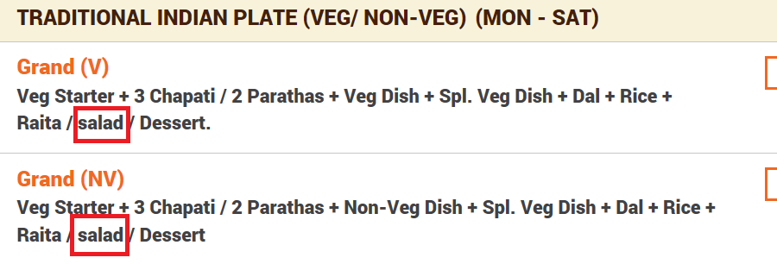

1. In customised plate: Chapati should be Chapatis. **Done**

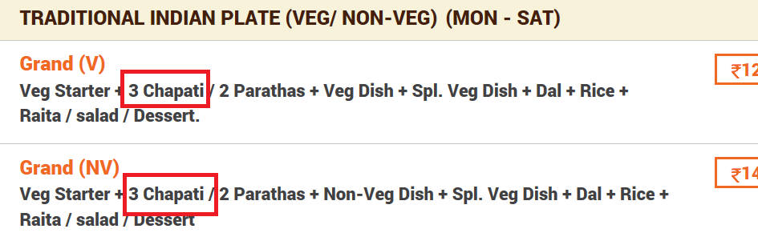

1. In customised plate: Remove dot. Done

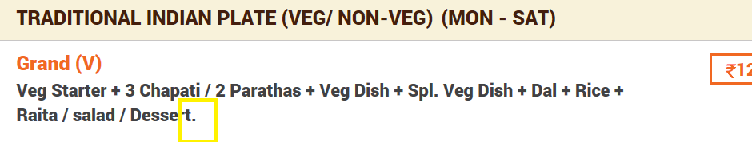

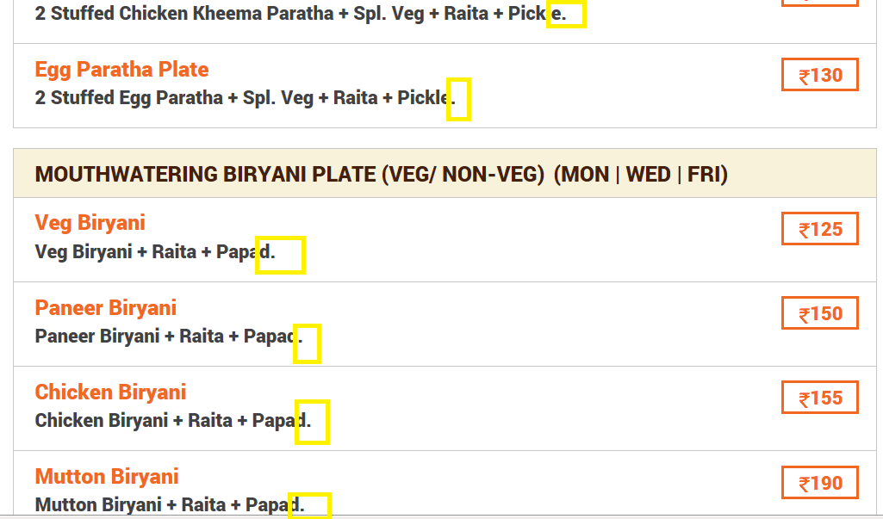

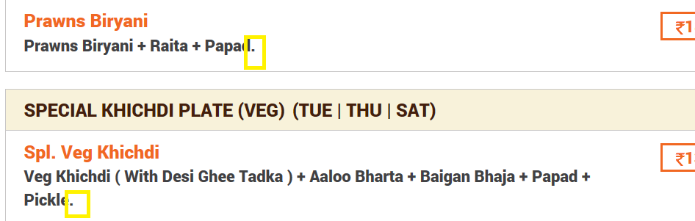

1. In customised plate: make the text **Done**

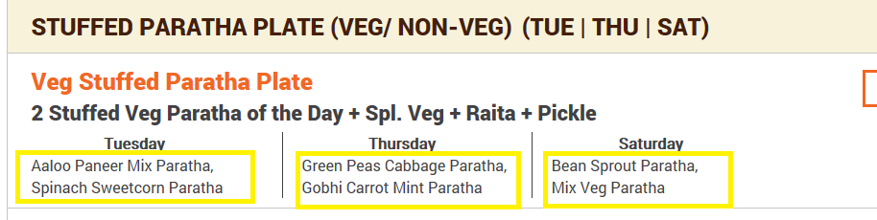

1. In the customised plate: Put Or where the yellow line has been placed. Remove comma. **Done – please review it , text was left aligned , now changed it to center align due to “Or “. Please revert email if you need any change.**

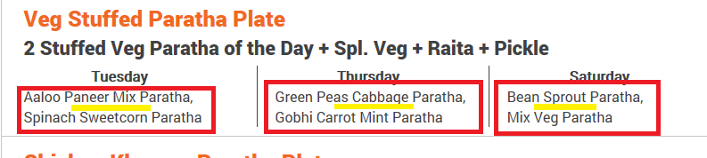

1. Check delivery area step- In this change the phone number to 9699 699204. Spelling of inquiry to be as enquiry. Make the change to check delivery area step wherever applicable. **Done**

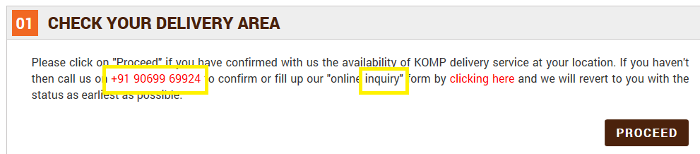

1. In the select start date- both the options 10 days and 22 days are not aligned. You can see the yellow line. 10 and 22 not aligned. **Done**

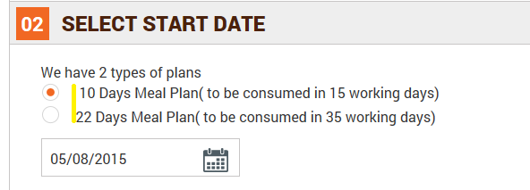

1. Choose your dates step: Remove * and align the 10 meals line with the second line. Remove 15 working days) highlighted in yellow as this is repetitive. Done

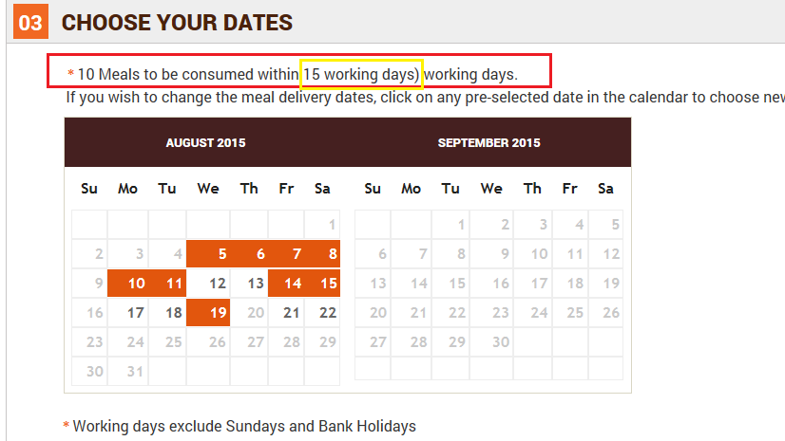

1. In the payment method step – please add another option – Cash Pick up. Also there will be an extra charge of Rs. 50 if a customer chooses this option. So when customer is placing an order then the amount should get added to as Cash Pick Up Charges in the same way we have online transaction charge for online payment. **Done**

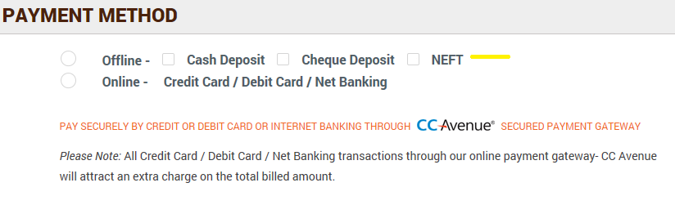

1. The login screen to be checked as the remember me is not working as previously also I have ticked the box but still I have to enter [sudhanshusharaan@gmail.com](mailto:sudhanshusharaan@gmail.com) again and again. It should actually prompt next time you login if once you have checked the box - remember me. -**Done**

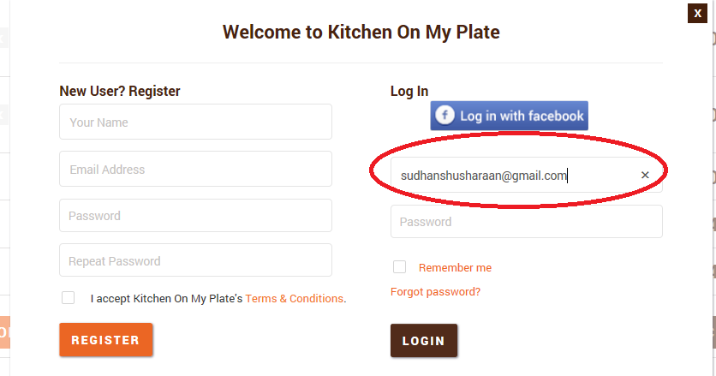

1. In the payment method: both the hyphens are not aligned. -**Done**

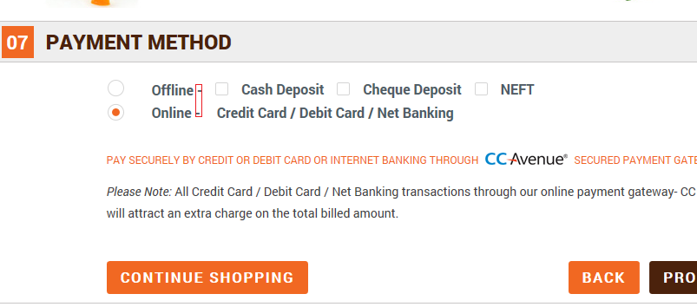

1. In the customised plate: after selecting start date, choosing the meal delivery dates, choose meals then you reach 06 step cart total, then 07 step – chose online mode of payment, then clicked on proceed. Reached step 08 Final amount to be paid – then there I deleted one order out of the two then you get 06 step cart total and goes straight away to 08 step final amount to be paid and that too on the same page.Needs to be rectified. The next step should be step 07 and on the next page. These steps cannot be on the same page. **Done**

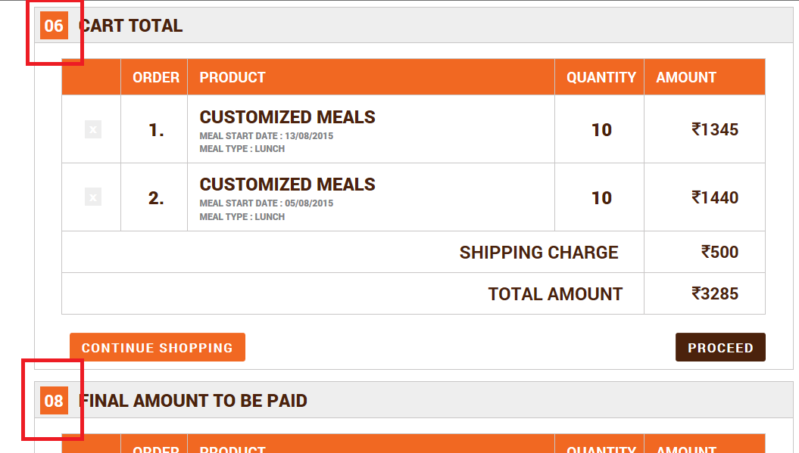

1. Select start date- I manually entered 30/08/2015 as the start date which is wrong because 30th Aug is a Sunday. I clicked on proceed after entering 30th Aug and it gave me the next step 03 choose your dates. This should not happen chosen start date is wrong. Infact if you see below screen shot it did not give the pre-selected dates as well. **Done** – below scenario is correct, if user type disable day then it should allow to populate preselected dates. But above concern needed to be created, it should allow only to select date, should not allow type date. I have restricted to user to type in date choose date.

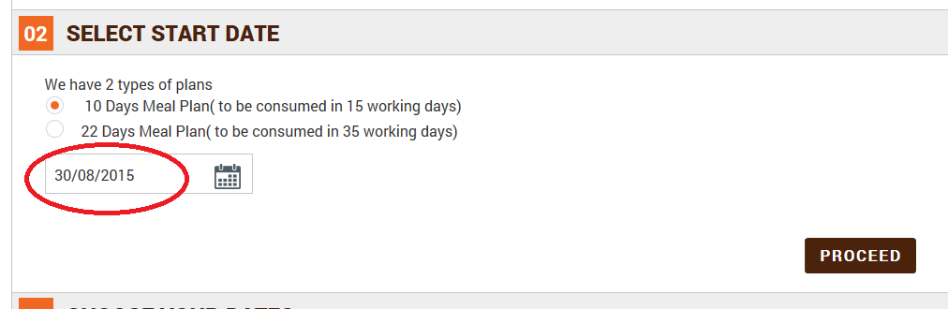

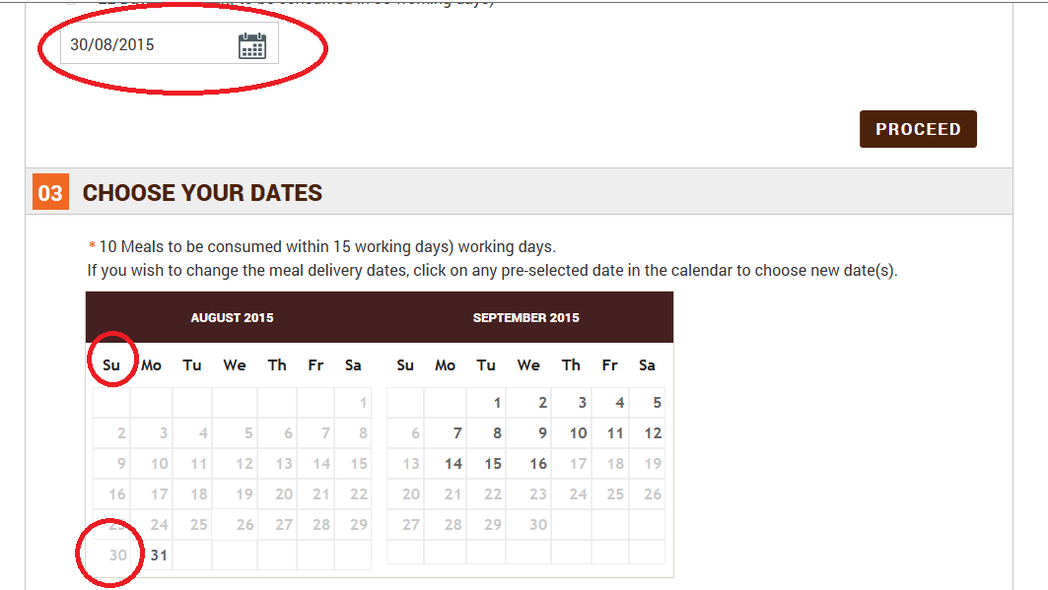

1. I am already logged in with Sudhanshu Sharan and on the 06 cart total page but it is asking to login again at step 08 to login page.

**Observing this issue, working on.**

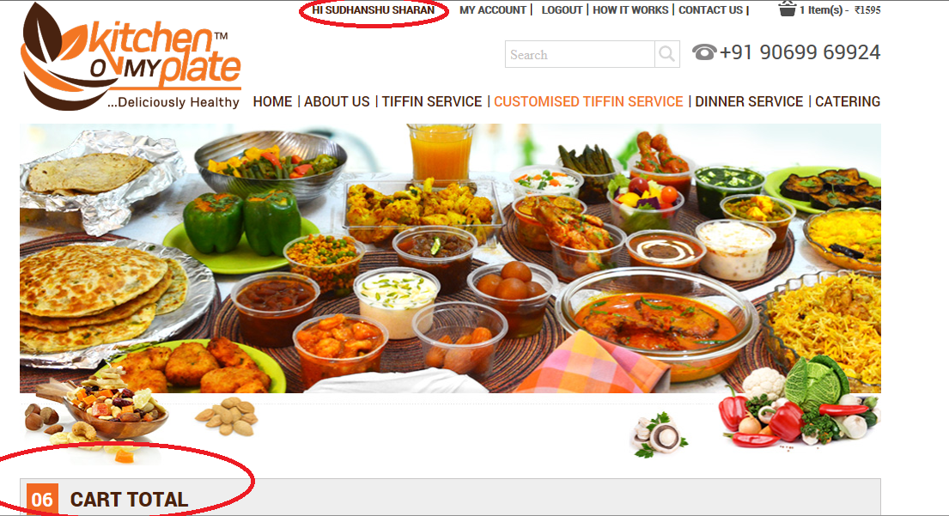

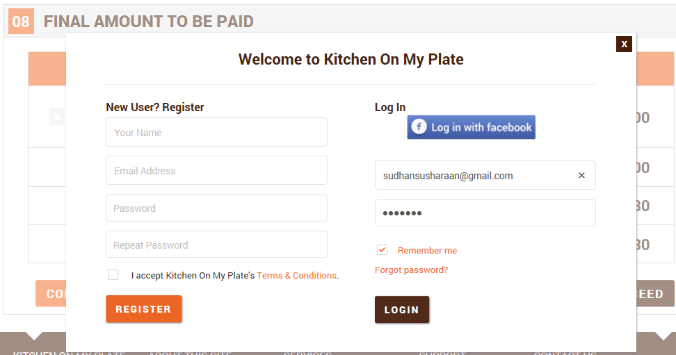

1. Here on the CC Avenue page customer is requested to put the details. It should automatically take the billing info from the data entered earlier by the customer.

**Here I need to call to CCAVENUE, It was working fine earlier, we are sending the correct parameters, today I will confirm again from our side, else tomorrow will call to ccavenue.**

